Chapter 6: Interaction between organisms

6.1 All organisms are interdependent

Student worksheet answers (pages 102–103)

Food chains and food webs

1 Use the diagram of the owl to construct a food chain. Under each organism in the food chain, write whether they are a consumer or producer.

Wheat (producer) 🡪 mouse (consumer) 🡪 owl (consumer)

The following observations were made while sitting by a billabong.

Nymphs, water beetles and fish were observed eating algae and water plants. Dragonflies were seen consuming the water beetles and nymphs. A large black swan started feeding on the water plants, but also ate the nymphs and water beetles. A long-necked turtle also ate the water plants and water beetles. Then, a huge wedged-tailed eagle swooped down and plucked the turtle from the water and started to eat it.

2 Construct a food web to show the feeding relationships between the various organisms observed by the billabong.

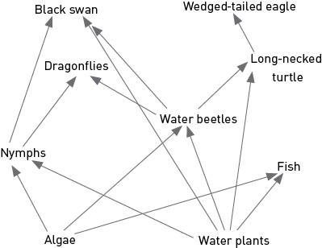

a What were the producers found at the billabong?

The producers were algae and water plants.

b What were the first-order consumers found at the billabong?

The first-order consumers were nymphs, water beetles and fish (and possibly the turtle and swan).

c What were the top consumers found at the billabong?

The top consumers were the black swan and the wedged-tailed eagle.

d Write one food chain from the description of the billabong.

Student responses will vary, but should start with either the algae or water plants as the producer and end with the top consumers.

3 Could the Sun also be included in a food chain or food web?

The Sun could be included at the start of the food chain or web as the arrows in a food chain show the movement of energy. Alternatively, the Sun cannot be included because the arrow would point to a producer, not a consumer.

EXTEND YOUR UNDERSTANDING

4 Research an example of a food web that does not start with the energy of the Sun.

Most such food webs occur in hostile environments, such as deep sea vents, and have bacteria or archaea as the primary producers. More information can be found at: <https://en.wikipedia.org/wiki/Chemotroph>

6.2 All organisms have a role in an ecosystem

Student worksheet answers (pages 104–105)

Ecosystems – energy for life

1 In most ecosystems, the Sun provides the energy for the producers. The producers convert the Sun’s energy into food through a process called photosynthesis. During this process, sunlight shining on the green leaf is converted to chemical energy by chlorophyll contained in the leaves, and is then used to convert carbon dioxide and water into sugar and oxygen. Use this description to label the arrows on the diagram.

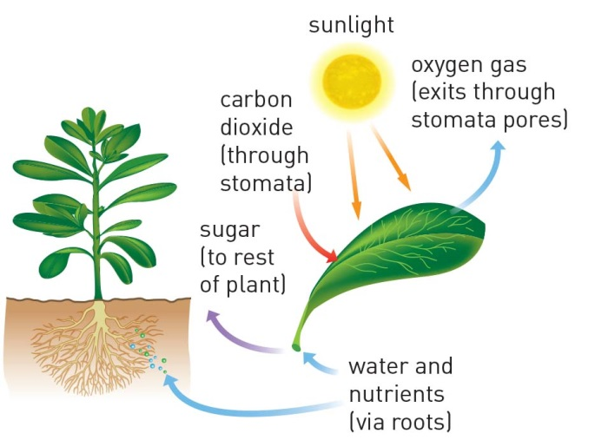

2 You may remember this description from the previous worksheet:

The following observations were made while sitting by a billabong.

Nymphs, water beetles and fish were observed eating algae and water plants. Dragonflies were seen consuming the water beetles and nymphs. A large black swan started feeding on the water plants, but also ate the nymphs and water beetles. A long-necked turtle also ate the water plants and water beetles. Then, a huge wedged-tailed eagle swooped down and plucked the turtle from the water and started to eat it.

a Which consumers are herbivores?

The nymphs, water beetles and fish are herbivores.

b Which consumers are carnivores?

The dragonflies and the wedged-tailed eagle are carnivores.

c Which consumers are omnivores?

The black swan and long-necked turtle are omnivores.

3 The cow in the image is in the process of being recycled by decomposers.

Fill in the flow chart below to show the cycle of nutrients and energy that this dead cow is part of in the ecosystem. Include the following information:

• the producer, consumers and decomposer

• carnivore and herbivore

• an example of the producer, consumer (other than the cow) and the decomposer.

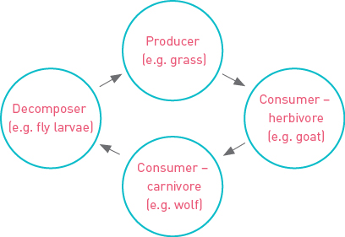

EXTEND YOUR UNDERSTANDING

4 Find out how a worm decomposes dead organisms and how this is linked to the health of the soil in a garden. The following website may be a useful place to start: <http://www.dpi.nsw.gov.au/agriculture/resources/soils/biology/earthworms>

You could present your findings as a one- to two-paragraph written response. A diagram may also be worthwhile.

• Worms feed on dead plant and organic matter in soil (such as dead roots, leaves, grasses, manure).

• The digestive systems of worms act to concentrate the minerals and organic materials in all of the foods they eat, so their casts (faeces) are richer in nutrients than the soil around them.

• The earthworm casts are high in a chemical element that many plants need to grow. The nitrogen is easily absorbed by plant roots. When earthworms die, their bodies decompose very quickly. This also acts to increase nitrogen and other nutrients in the soil making it healthier.

6.3 Food webs can be disrupted

Student worksheet answers (pages 106–107)

Balance in the food web

1 You may remember this description from a previous worksheet:

The following observations were made while sitting by a billabong.

Nymphs, water beetles and fish were observed eating algae and water plants. Dragonflies were seen consuming the water beetles and nymphs. A large black swan started feeding on the water plants, but also ate the nymphs and water beetles. A long-necked turtle also ate the water plants and water beetles. Then, a huge wedged-tailed eagle swooped down and plucked the turtle from the water and started to eat it.

A year later at the same billabong, some significant changes were observed: the wedged-tailed eagle and long-necked turtle were not seen and there were significantly fewer dragonflies. However, there was a large number of European wasps flying around the billabong that were eating water beetles and nymphs, and were even attacking the dragonflies.

a Construct a food web to include the European wasps in the feeding relationships observed by the billabong. Draw the arrows in a red colour from the European wasps.

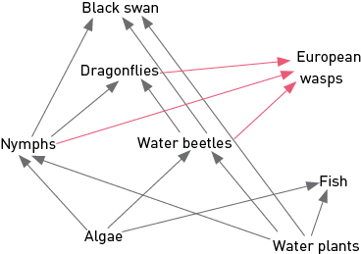

b What organisms did the European wasps feed on?

The European wasps ate the water beetles, nymphs and dragonflies.

c Which consumers would have normally eaten the organisms that the European wasps ate?

Normally, the dragonflies, black swam and long-necked turtle would have eaten the organisms the European wasps ate.

d Why do you think the long-necked turtle and the wedged-tailed eagle were not seen at the billabong?

The European wasp was feeding on the food that the turtle would normally eat, so there was less food for the turtles, meaning there were fewer turtles in the environment. The wedged-tailed eagles may have eaten the remaining turtles, then moved away from the billabong to find another source of food.

e Were there any organisms that were predators of the European wasps?

No organisms predated upon the European wasps.

f How do you think the European wasps may change the billabong in the future?

Student responses will vary, but the European wasps would probably have an impact on the black swan population because they would eat part of the swans’ food source. The fish population may increase because their predators will have gone.

2 How does the loss of amphibians affect humans?

In areas of the world where amphibian populations have declined there has been an increase in invertebrate pests (mostly insects) that damage crops and carry human diseases.

3 If 1000 frogs consume approximately 5 million invertebrates per year, how many invertebrates does each individual frog consume in:

a one year?

5000 invertebrates

b one month?

417 invertebrates

c one week?

104 invertebrates

d one day?

15 invertebrates

EXTEND YOUR UNDERSTANDING

4 Different methods have been used around Australia to control the number of European wasps in the environment. One method uses another type of wasp whose scientific name is *Spechophaga vesparum*. This is a parasitic wasp. Use the Internet to discover:

a when this parasitic wasp (*Spechophaga vesparum)* was introduced to Australia

Spechophaga vesparum was introducing into Australia in 1989.

b how it controls the European wasp population in Australia

*Spechophaga vesparum* only attacks the European Wasp. It enters the nests of European wasps and feeds on the developing larvae and pupae so that these do not hatch.

c whether it has been effective.

The parasitic wasp has helped reduce European Wasp numbers to manageable levels.

6.4 Human activity can affect local habitats

Student worksheet answers (pages 108–109)

Habitat destruction

1 Label the diagram of the Amazon rainforest below to summarise how human activities have affected this ecosystem. The words below can be used as a starting point, but you should try to include a little more detail too.

• The trees have been cut down for…

• The land has been cleared for…

• The river is brown because…

• The burning trees cause…

• Pollution in this area comes from…

• The remaining habitat is under threat from…

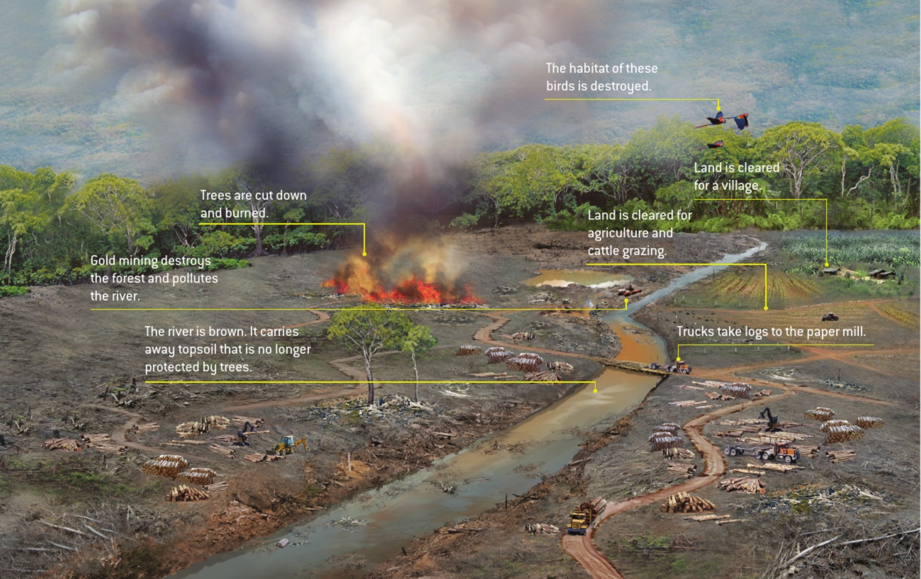

EXTEND YOUR UNDERSTANDING

2 Use your understanding of climate change and undertake further research to find out how the Amazon rainforest may change in the future.

Student responses will vary greatly depending on the depth of research and detail of the response. The following website provides a summary of some issues: <http://www.wwf.org.uk/where_we_work/south_america/amazon/amazon_and_climate_change.cfm>

6.5 Science as a human endeavour: Isolated populations can be used as case studies

Student worksheet answers (pages 110–111)

Isolated populations

1 As you can see from the image below, Easter Island is not completely treeless. There are certain locations where trees have returned to the ecosystem.

a Look carefully at the map above, especially near Hanga Roa. What evidence is there that humans live on Easter Island?

There is evidence that humans live near Hanga Roa because of the roads and an airport.

b Make an educated guess to describe how trees have returned to Easter Island.

Student responses will vary, but may include: humans planted the trees; seeds from the original trees may have germinated; seeds may have floated to the island by sea; and birds may have dropped the seeds on the island.

c Can you think of anyway these trees may have returned naturally to Easter Island?

Student responses will vary, but may include that seeds from the original trees may have germinated, seeds may have floated to the island by the sea or birds may have dropped the seeds on the island.

d Look carefully at the photograph of Easter Island. What animals can you see?

Horses can be seen.

EXTEND YOUR UNDERSTANDING

2 Research the animals and plants that exist on Easter Island and draw a food chain based on your findings.

Because of its extreme isolation, the variety of animals on Easter Island is limited. It has no native mammals. The first Polynesian settlers introduced Maori rats to the Island and there are two species of reptiles: a gecko known as *moko uru-uru kau* and a lizard known as *moko uri uri*. There are many birds on the Island, both native and introduced, including finches, frigatebirds, the masked booby and a hawk species. The fish around the Island include the poopó, yellowtail fish, mahi-mahi and tuna. There are also various turtle species. Possible food chains include:

grass → Maori rat → hawk

algae → yellowtail fish → masked booby

6.6 Science as a human endeavour: Environments can be responsibly managed

Student worksheet answers (pages 112–113)

Managing ecosystems

1

a What are ‘green wedges’ or ‘green belts’?

Green wedges or green belts are undeveloped land set aside within a city as a way of ensuring there are green areas with plants and animals within suburbs and cites.

b Why are ‘green wedges’ or ‘green belts’ important?

These active, living areas protect a city’s open spaces and natural areas from too much building (over-development). Green belts provide important habitats for animals.

2

a What are ‘green corridors’?

Green corridors are sections of bushland or grassland that often link green belts or wedges.

b Why are ‘green corridors’ important to animals and humans?

Green corridors allow animals to move from one location to another, through farmland or developed areas. Young animals can use these corridors to move out and form their own territories. These areas benefit farmers by acting as windbreaks and shelterbelts; they also provide natural environments for humans to enjoy.

3 Look at the image of the ‘sporting precinct’ of Melbourne. Describe the benefits of this ‘green wedge’ to:

a animals

Animals can live quite safely in this green wedge, which is also linked with green corridors. There appears to be plentiful water and, more than likely, food sources.

b people

People benefit from this green wedge by having a natural environment close to the city and the sporting precinct.

4

a What is a ‘seed bank’ or ‘seed vault’?

Seed banks or vaults store seeds for planting if other seed reserves die out. Seeds of important crop plants or even rare plants may be stored.

b Why is a ‘seed bank’ or ‘seed vault’ useful for the future?

The seeds stored in a seed bank could be used to breed new varieties of crops, or to store seeds of existing crops, or to provide a backup plan in the case of natural disasters, which may pose a threat to food production.

EXTEND YOUR UNDERSTANDING

5 Kakadu National Park in the Northern Territory is one of Australia’s most precious ecosystems. It is home to a range of environmentally and culturally significant sites. Research some of the ways this ecosystem is managed and protected, then fill in the bubble chart below with a summary of the information you have discovered.

Student responses will vary depending on the depth of their research. The following website provides a range of management techniques used at Kakadu National Park: <http://www.environment.gov.au/topics/national-parks/kakadu-national-park/management-and-conservation/park-management>

6.7 Science as a human endeavour: Modern land managers use traditional Indigenous techniques

Student worksheet answers (pages 114–115)

Indigenous techniques for managing ecosystems

1 Use the table below to fill in the positive and the negative effects of the firesticking farming practices of Indigenous Australians. Many of the positive effects are in the text, but you will need to also think about the negative effects.

|  |  |  |  |
| --- | --- | --- | --- |
| Effects on humans | | Effects on the ecosystem | |
| Positive | Negative | Positive | Negative |
| Student responses will vary but could include:  • hunting becomes easier  • new shoots encourage more herbivores | Student responses will vary but could include:  • fire may cause death or injury  • waterways could become polluted from ash | Student responses will vary but could include:  • fire clears the undergrowth, which could reduce unplanned bushfires  • the practice eventually provides new shoots for herbivores | Student responses will vary but could include:  • the unnatural destruction of ecosystems  • death and injury caused to animals |

2 Examine the painting below.

Describe the environment:

a before firestick farming.

Student response will vary, but the environment may have had more bush and less grassland. Animals would be living in their habitat.

b during firestick farming.

The environment has a fire travelling through the bush in the valley. Animals would be fleeing their habitat or be killed by the fire or hunters.

c one month after firestick farming.

Student responses will vary. The environment would still be charred after the fire, but some shoots may be appearing. Very few animals would have returned.

d five years after firestick farming.

Student responses will vary. The environment would be recovering from the effect of firestick farming. Trees would have revegetated, undergrowth would be growing and many animals would have returned.

EXTEND YOUR UNDERSTANDING

3 How are eucalyptus trees able to survive bushfires? Research this and record your findings.

Some trees and shrubs have buds buried deep within their trunk. Once a fire has removed all the leaves, the buds soon sprout, covering the tree in new leaves and branches. Seed banks on the plants, whereby certain plants store their seeds within hard fruits to protect the seeds, will open a few days after the fire has passed through.